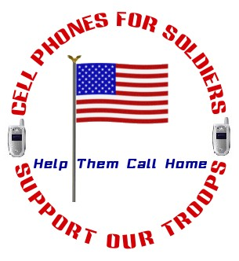

Donation Receipt

Thank you for your donation to the Cell Phones For Soldiers program, a 501(c)(3) non-profit organization (TAX ID# 20-1343425). The Cell Phones for Soldiers program provided no goods or services in consideration for your donation.

The program makes no determination of the value of the donation. Please consult your tax advisor.

Please accept this as acknowledgement of your donation. Please complete the information below and keep this for your tax purposes.

_______________________ _______________________
Date of Donation Value of Donation

Thank you for your support.



Website: www.cellphonesforsoldiers.com

Cell Phones For Soldiers
243 Winter Street
Norwell, MA 02061
1-800-426-1031

